t

**Goal:**

For this sprint we want to have search listing and see reviews of service providers

**Task Listing:**

**User Story 1 (8) -** “As a service provider I want to be able to see my own profile in its public state so that I know what others are seeing”

* Task 1 (4 hours) - on profile page have current information including profile image
* Task 2 (2 hours) - have profile information be prefilled when you go into the editing field
* Task 3 (2 hours) - implement figma mockup into app as user interface

**User Story 2 (8) -** “As a user I want to be able to search for posts based on key term, so that results are relevant”

* Task 1 (2 hours) implement key term search
* Task 2 (2 hours) implement location key term search
* Task 3 (1 hour) have only relevant posts show up

**User Story 2.5**(3) “As a service provider, I want to add tags to my posts, so that my services are advertised toward people looking for my specific skill set.”

* Task 1(1 hour) implement tag adding ui
* Task 3(.5 hours) figure out firebase structure for tags on posts
* Task 3(1 hour) connect ui to firebase

**User Story 3 (13) -** “as a user I want to be able to rate the service providers that I used so that everyone can see how they did”

* Task 1 (1 hours) make a rating variable to store in the user information that is alterable but not required, also include a total reviews (so that you can calculate the average)
* Task 2 (4 hours) implement a “rate this service button” that will prompt the user to rate the service out of five and then store that information back into the database -> most likely as an average of what is already in there -> so in this case we will also need total reviews per person
* Task 3 (2 hour) include the rating in some form in the user profile page along with the listing page

**[spike]User Story 4 (2)** “figure out why the canvas is not working in the profile view”

* Task 1 (2 hours)debug profile page to find why canvas is not working so that we can code more efficiently in that view

**[spike]User Story 5 (2)** “go through messaging tutorial in swift”

Total SP: 34

Total ideal hours:

**Team member Roles:**

**Scrum Master:**

**Satoki Ohashi: will work on HomeView**

**Initial Task Assignment:**

Dillon - User Story 2.5

Colton - User Stories 4, User Story 1

Satoki - User Stories 1, 2, 3, Spike 4

Ethan - User Stories 1, 2, Spike 4

Sam - User Story 3

**Burnup Chart:**

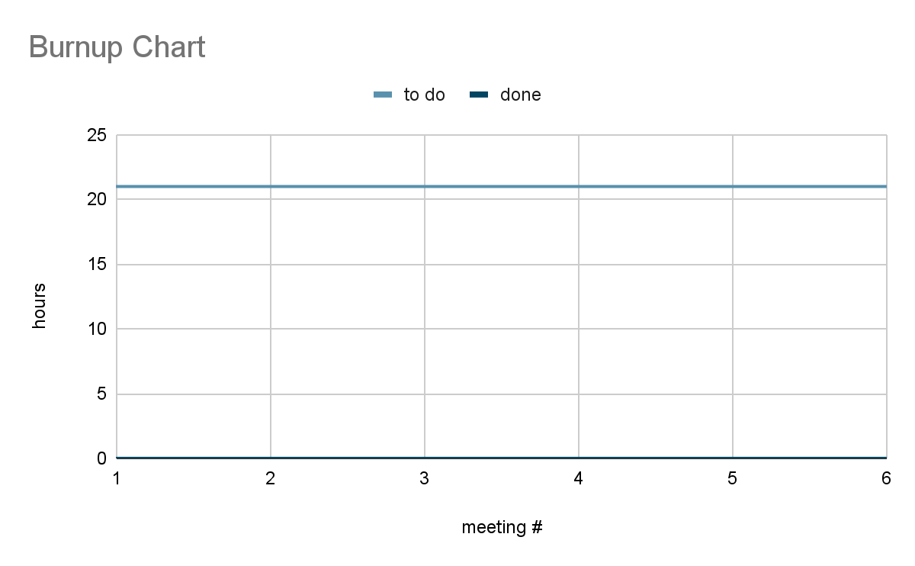

**Scrum Board:**

**Scrum Times:**

Monday, Wednesday, Sunday 12:00 - 12:15

//to do today!!!!!

//sprint 3 email

//sprint retrospective

//definition of done

//coding standards

//everyone do the tsr

//next week do specific thing that you built

//do swift recommended best practices